REST - Get Country Based on Country Code
Scenario: Write a REST service that returns a specific country based on a case-insensitive country code. The service exposes a GET endpoint at /countries/{code}, implemented in the CountryController class, which delegates to a CountryService that loads the country list from country.xml and matches the code using a case-insensitive lambda filter.

What Was Done
• Created country.xml under src/main/resources with multiple Country beans (India, USA, UK) and a countryList bean referencing all of them.
• Created a service package and added the CountryService class inside it, annotated with @Service.
• Implemented the getCountry(String code) method in CountryService, which loads country.xml, retrieves the countryList bean, and uses a stream with a lambda filter to find a country whose code matches the given code, ignoring case.
• Updated the existing CountryController class to autowire CountryService and added a new method getCountry(@PathVariable String code) mapped to GET /countries/{code} using @GetMapping.
• The controller method simply invokes countryService.getCountry(code) and returns the result.
• Added SLF4J logger statements at the start and end of both the controller method and the service method.
• Ran the Spring Boot application and confirmed Tomcat started successfully on port 8083.
• Verified the endpoint in Chrome browser and checked the response headers using Chrome DevTools Network tab.
• Verified the endpoint in Postman and checked the response headers using the Headers tab.

Result
The REST service was created and tested successfully. Hitting http://localhost:8083/countries/in in both Chrome and Postman returned the expected JSON response {"code":"IN","name":"India"} with HTTP status 200 OK. The case-insensitive matching worked correctly, and the application console confirmed the start and end log messages were printed in the correct order across both the controller and service methods on every request.

country.xml Configuration and Project Structure
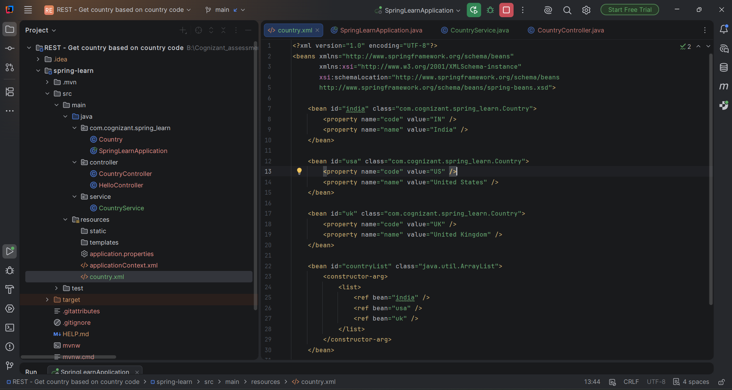
Figure 1: country.xml defining india, usa, and uk beans, along with a countryList bean combining all three.

CountryService Implementation
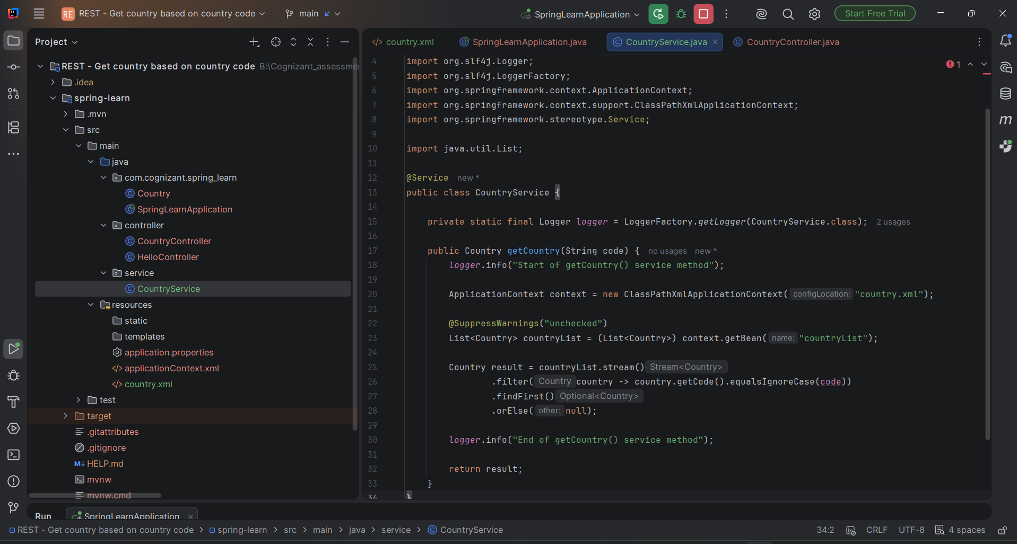
Figure 2: CountryService.java loading country.xml, fetching the countryList bean, and using a lambda filter with equalsIgnoreCase to find the matching country.

CountryController Implementation
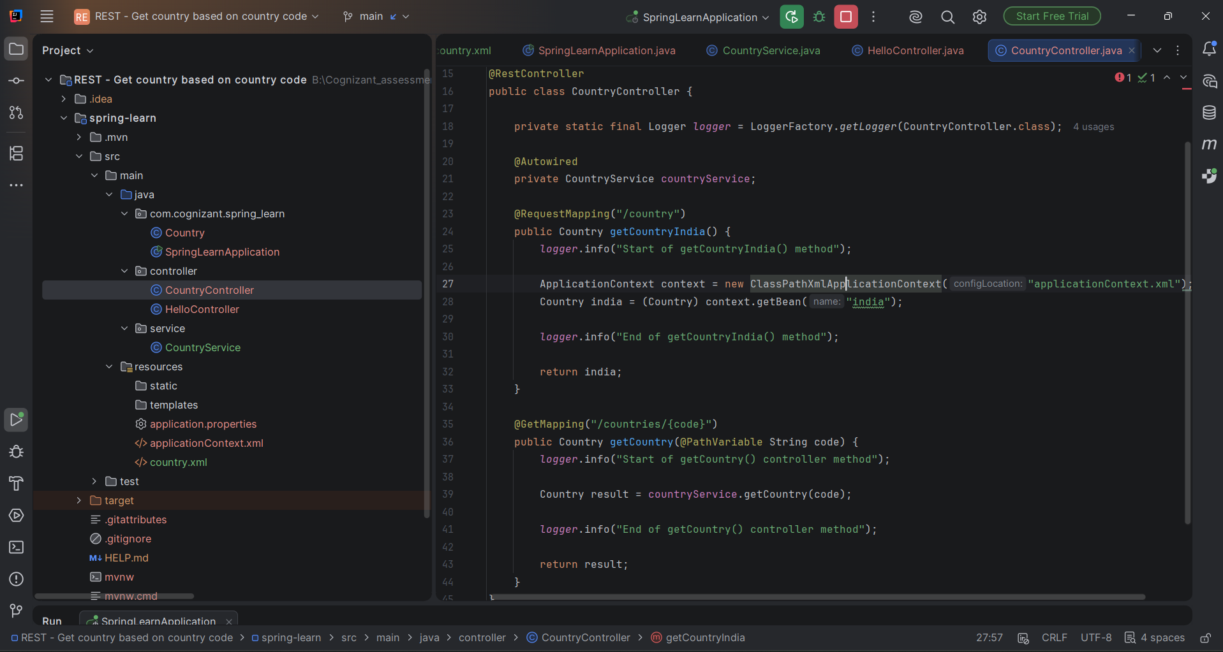
Figure 3: CountryController.java showing the existing /country endpoint alongside the new getCountry() method mapped to /countries/{code}, which delegates to countryService.getCountry(code).

Application Console Logs
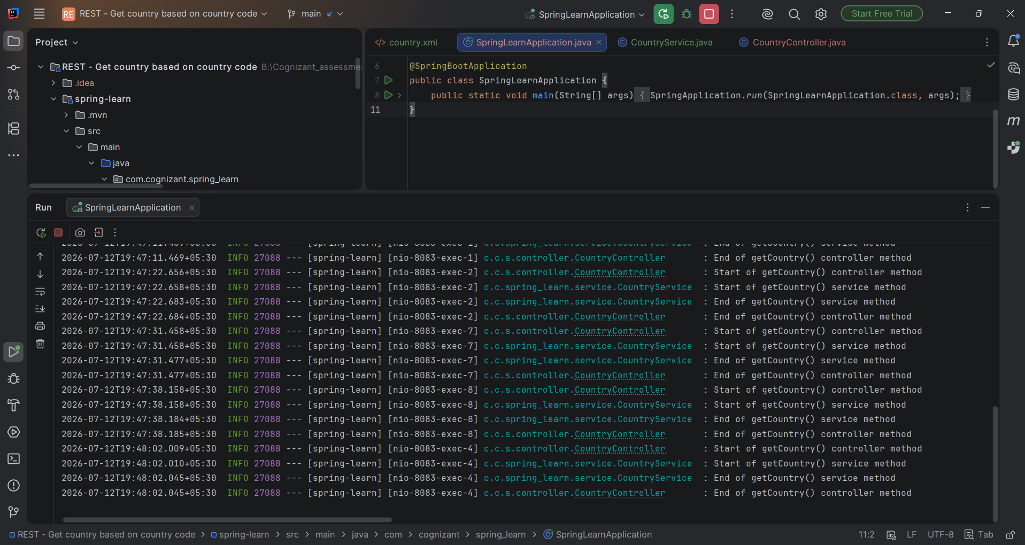
Figure 4: Console output showing the Start/End log sequence for both the controller and service methods on each request to /countries/{code}.

Testing in Chrome Browser
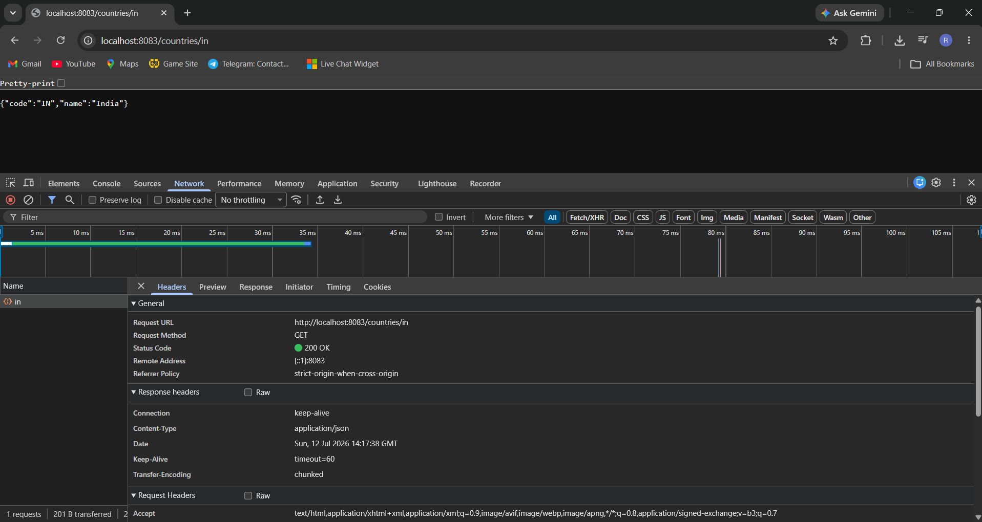
Figure 5: Chrome browser displaying the JSON response for /countries/in and DevTools Network tab showing response headers, including Content-Type as application/json.

Testing in Postman - Response Body
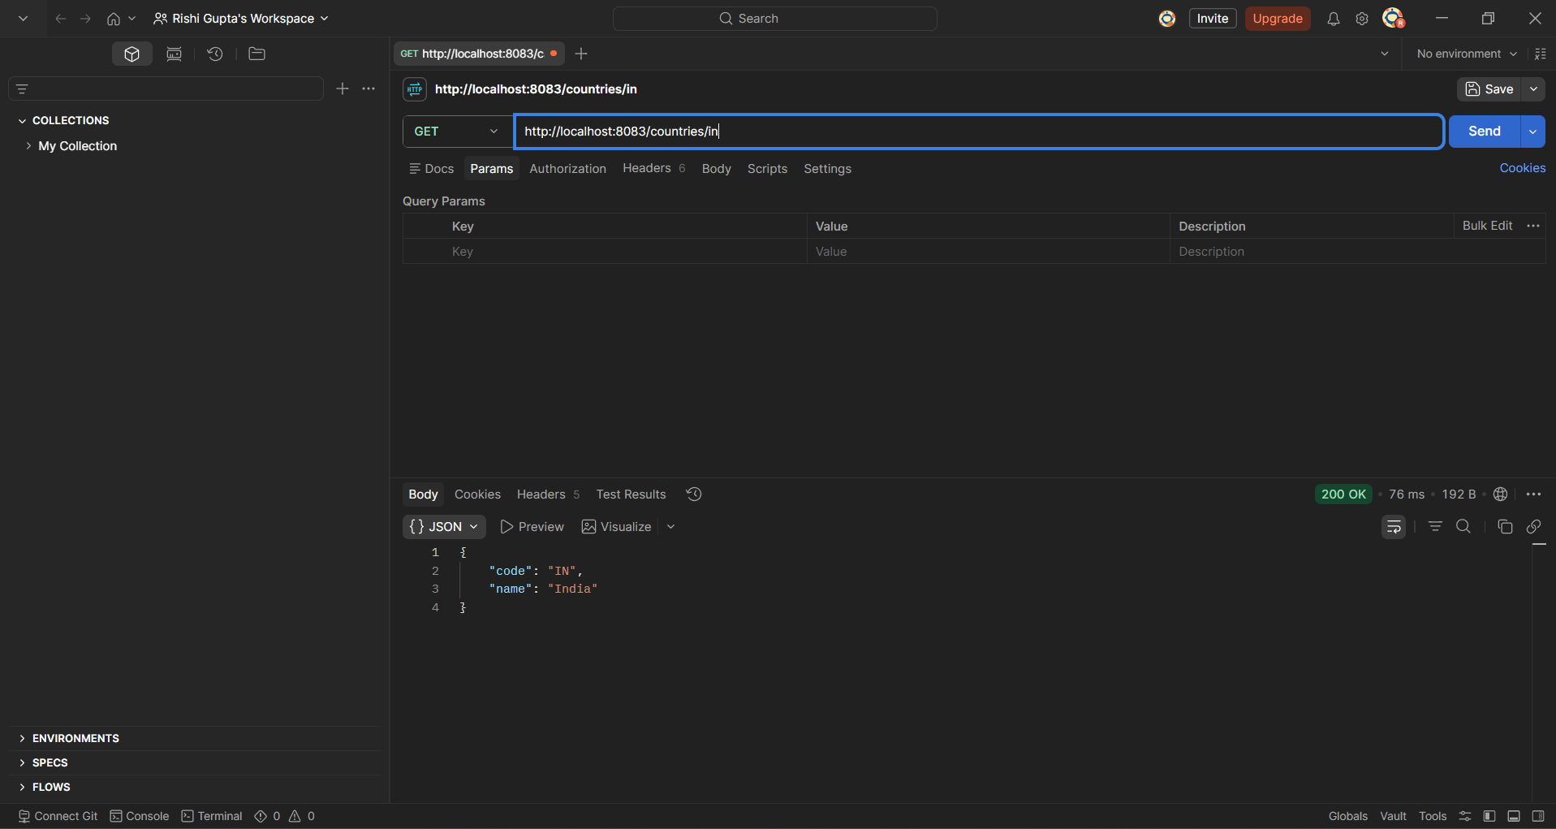
Figure 6: Postman GET request to http://localhost:8083/countries/in returning status 200 OK with the JSON body.

Testing in Postman - Response Headers
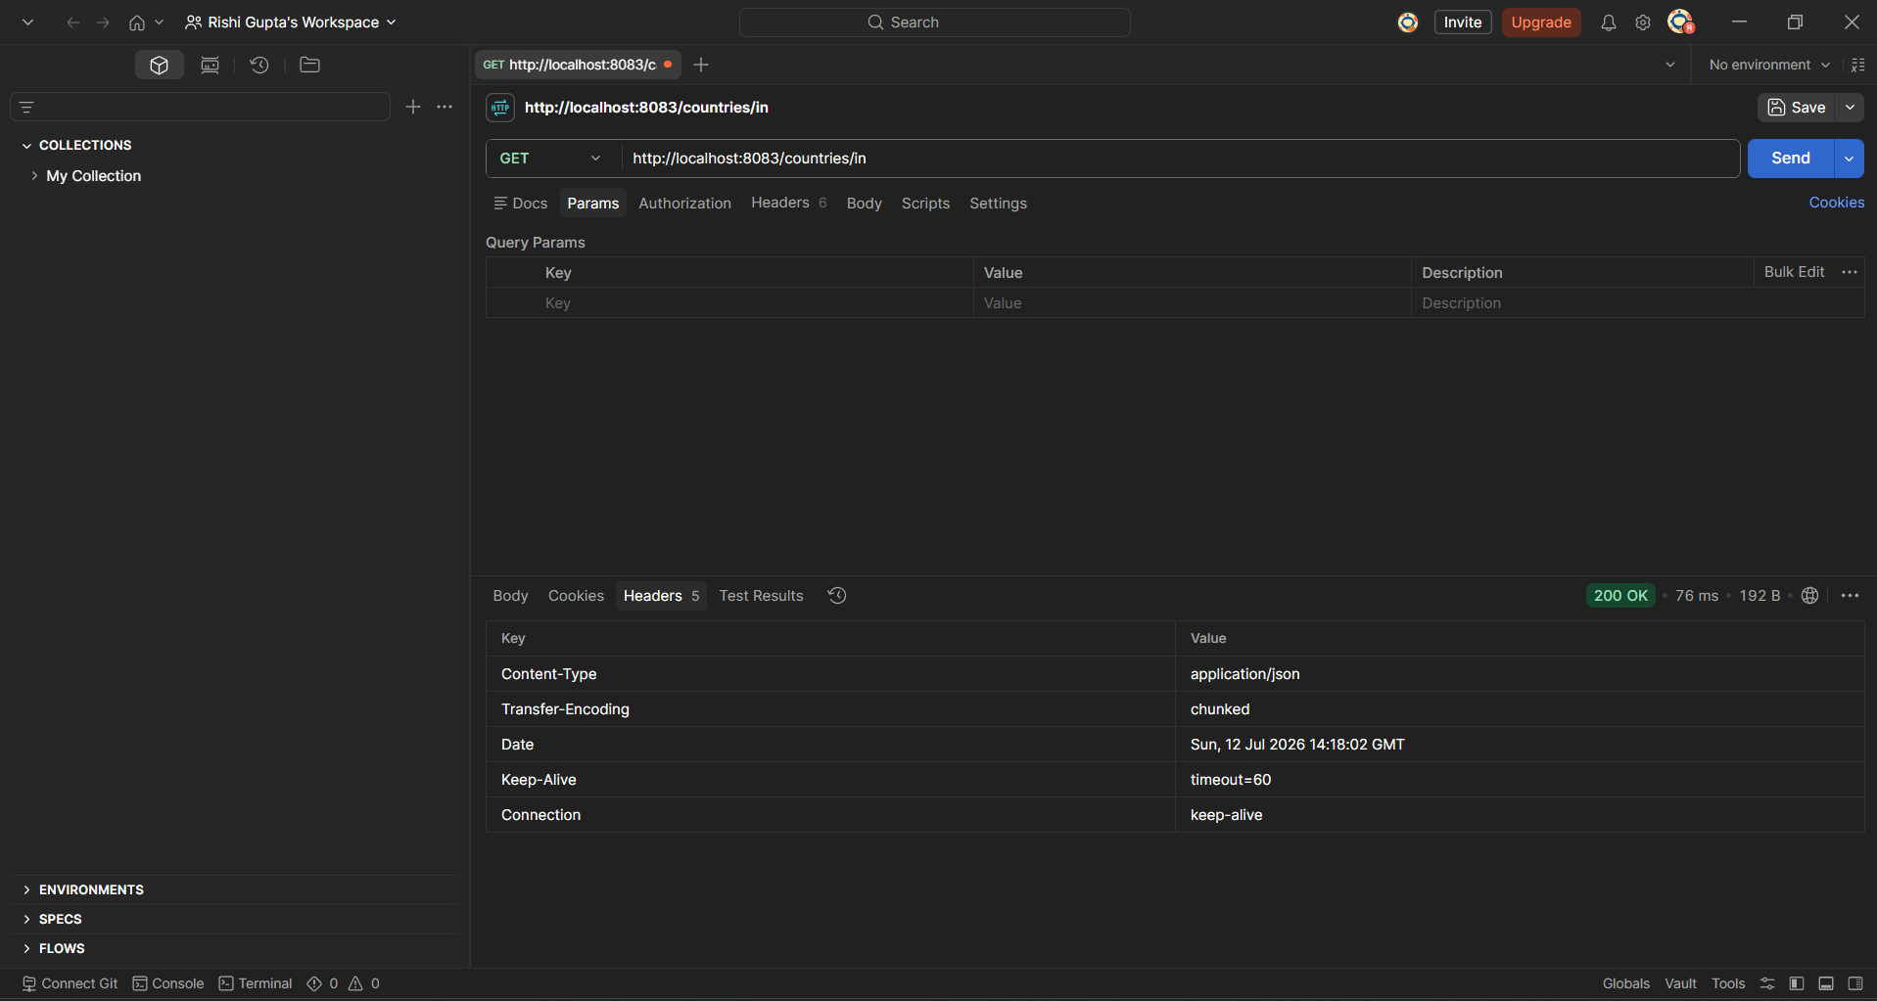
Figure 7: Postman Headers tab showing response headers received from the server.

